LAB-3(2403A52033)

TASK-2

Use copilot to generate is_prime() python function

Prompt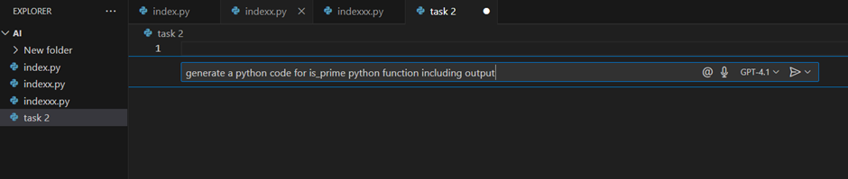

Code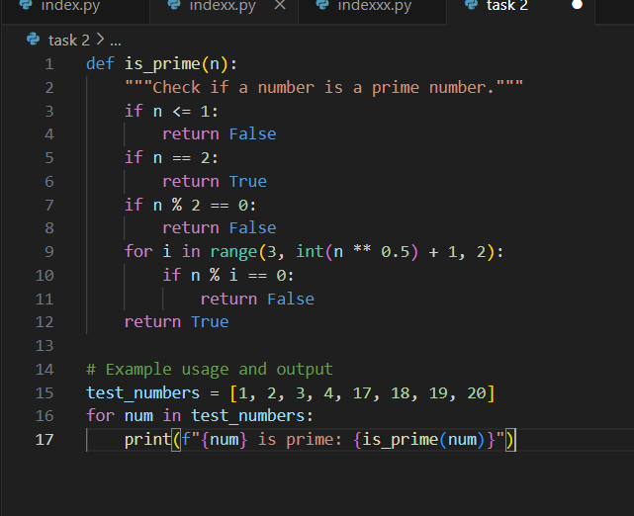

Output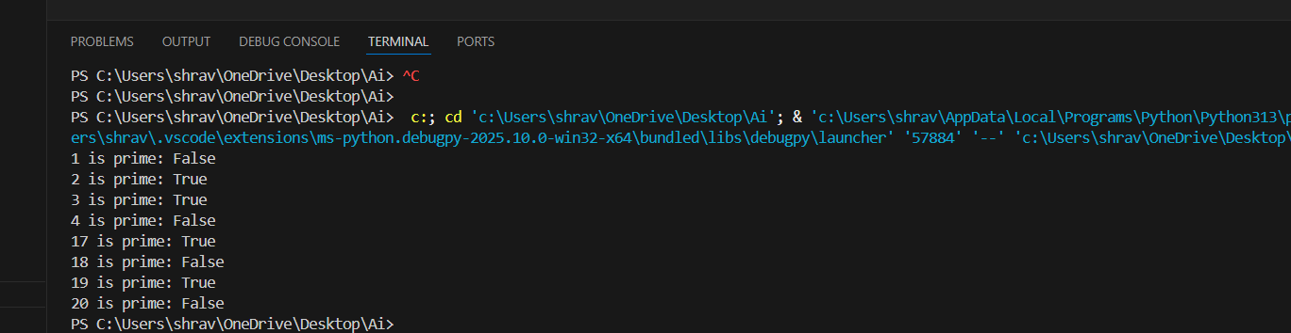

TASK-3

Use copilot to generate a function to reverse a string

Prompt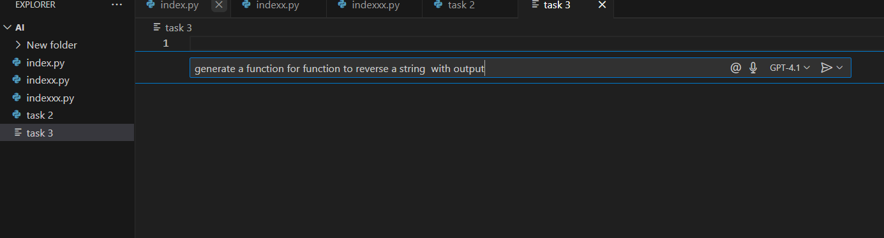

Code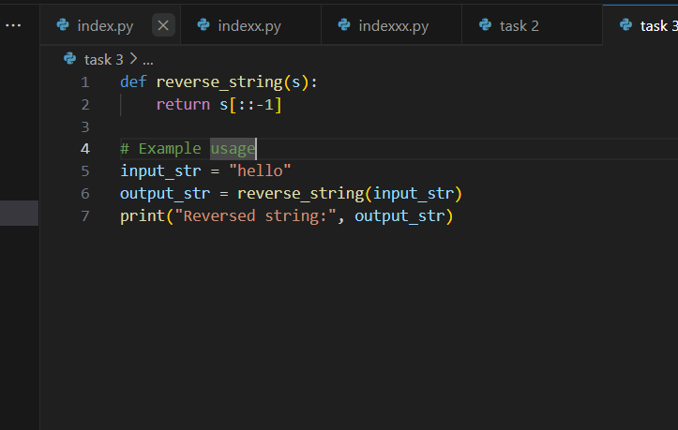

Output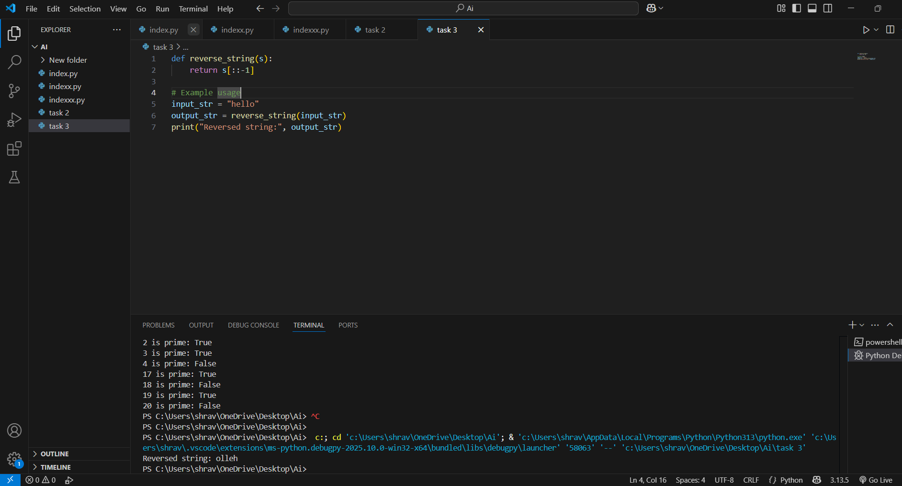

TASK-4

Use copilot to generate both recursive and iterative versions of a factorial using comments

Prompt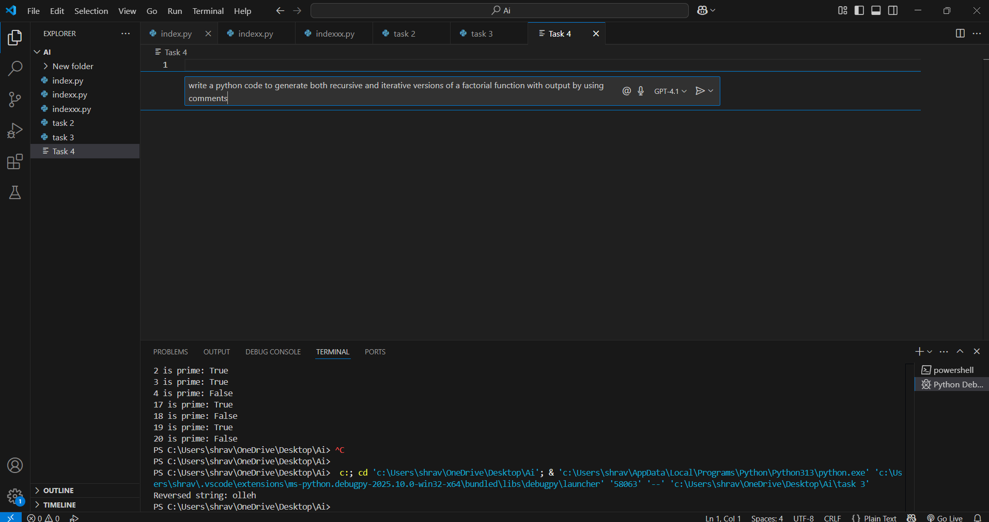

Code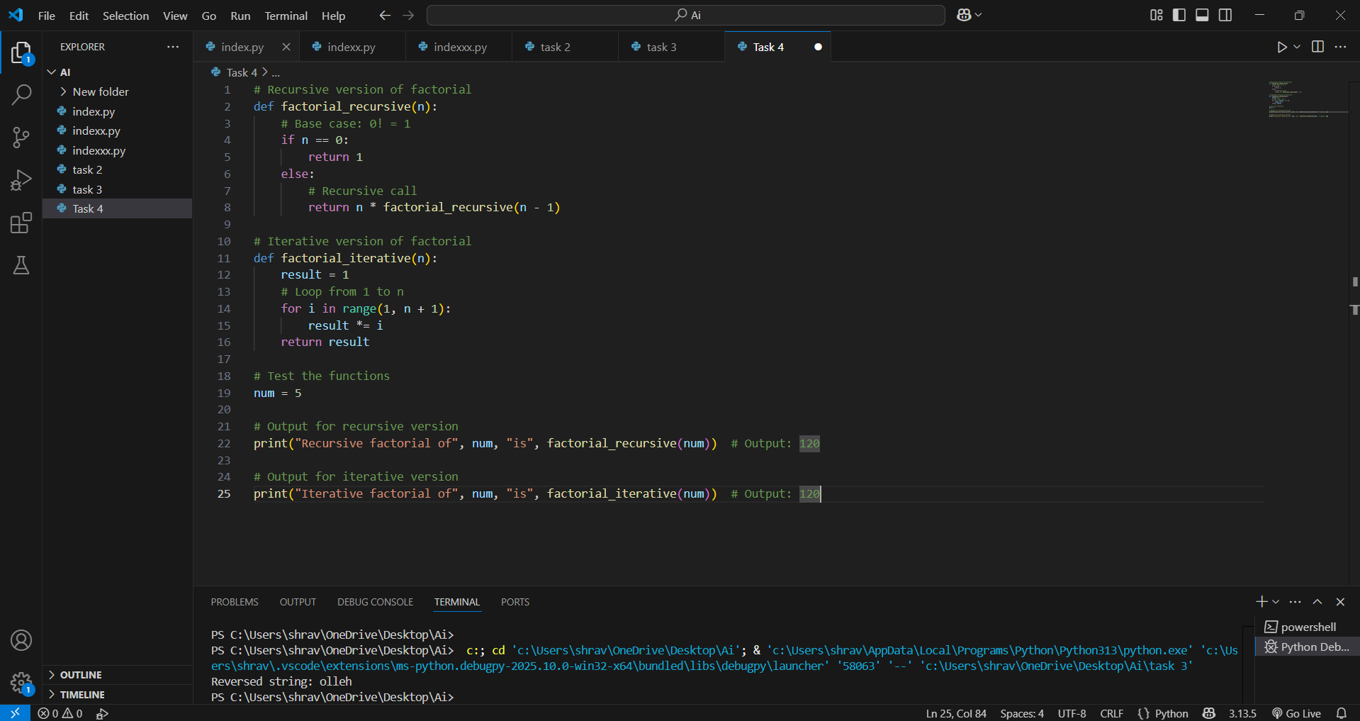

Output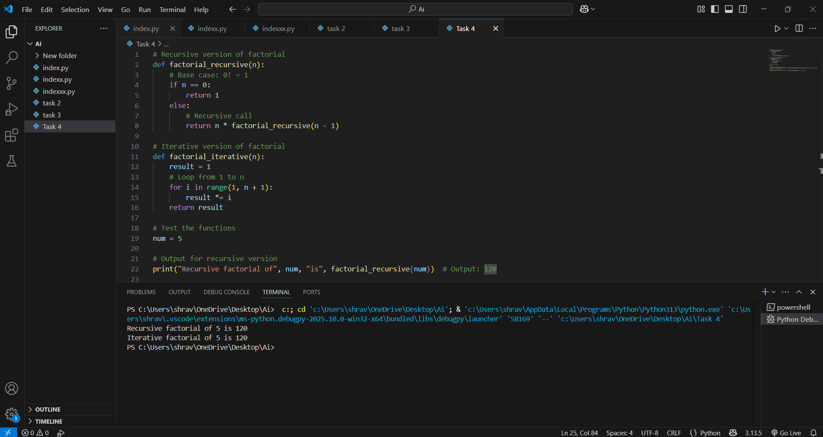

TASK-5

Use Copilot to find the largest number in a list Assess code quality and efficiently

Prompt

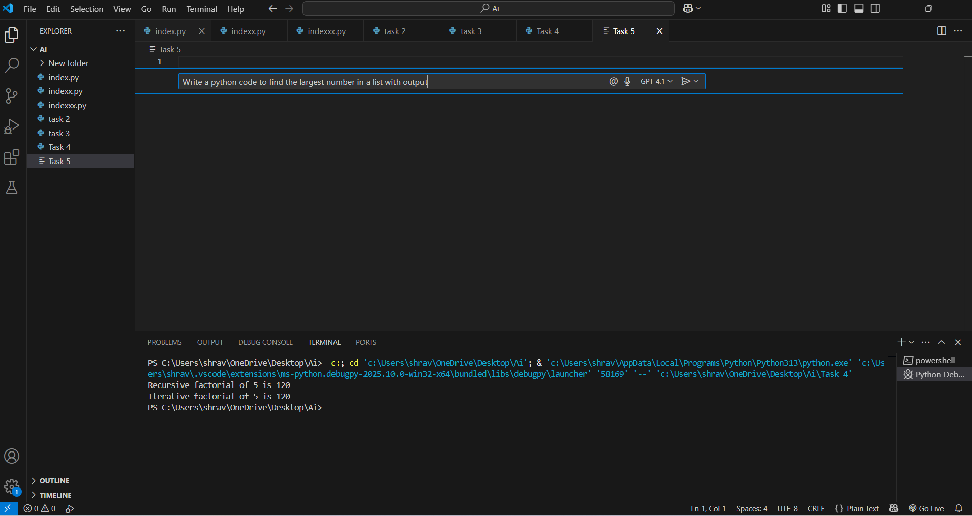

Code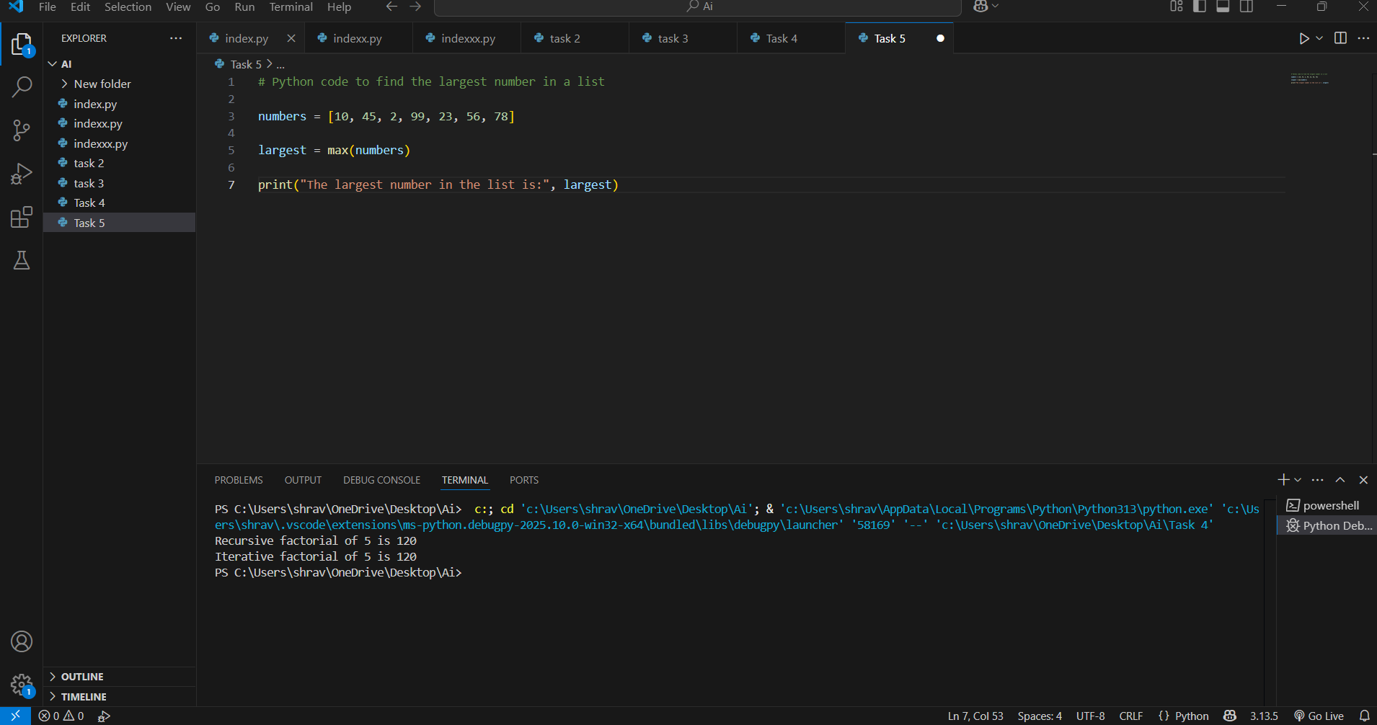

Output